Summary
The forecast results showed that there was a difference in the numbers of months that sales were predicted. The forecast predicted an upward trend of sales in the Year 2017.

The dates are set for the year and month interval. In spss Goodness of fit, Display forecast in statistics, Minimum absolute percentage error, maximum absolute percentage error in plots, predicted values in save were selected were selected. The forecast period was Year - 2017, Month - 9
The annual forecast for 2017 was
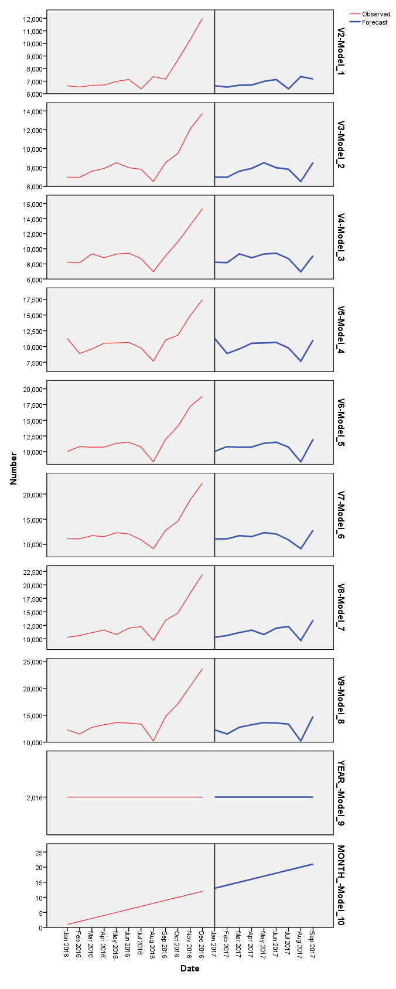

There was a predicted upward trend of sales for the year 2017 September.
The observed and forecasted sales for the previous years was similar

2.) The monthly forecast for the periodic Year 2017 was
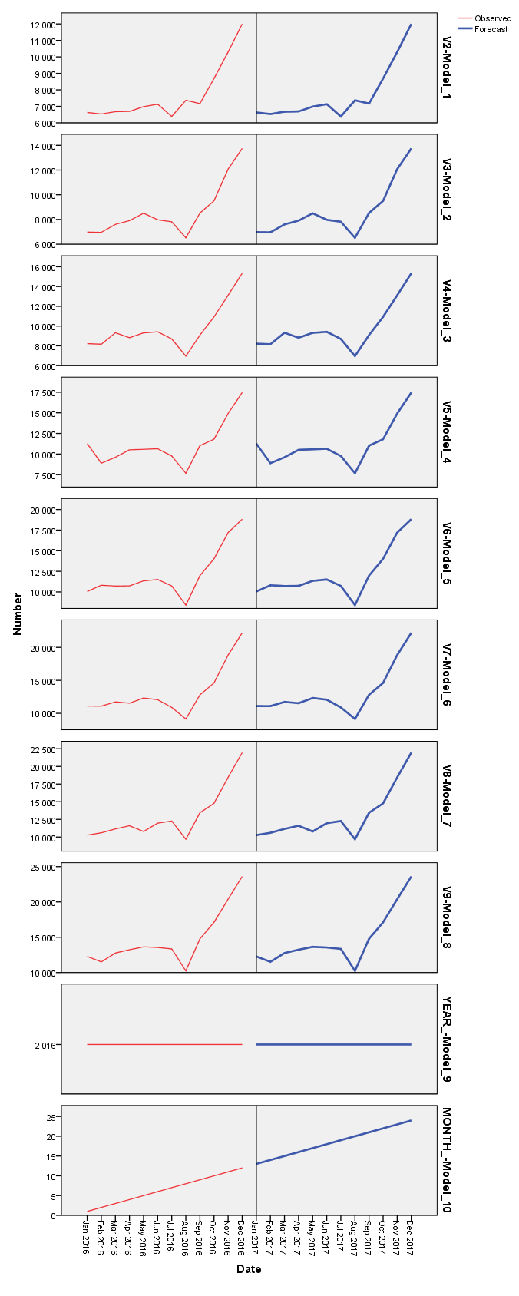

3.) There was a difference in the forecasts. The forecast for the year 10/2016 to year 9/2017 were: 13, 14, 15, 16, 17, 18, 19, 20, and 21. Which was different from the forecast of the 12 months which were: 13, 14, 15, 16, 17, 18, 19, 20, 21, 22, 23, and 24.

